Expediently Modeling Global Demand for Corn
This project begins with modeling the market demand curve for corn. That is, we have quantity demanded (here, measured by Total Usage from the USDA) as a function of price (here, the Marketing Year Average or “MYA” price). The Law of Demand requires the relation between quantity demanded and price not be positive. For modeling simplicity, we assume a downward sloping line, a linear demand curve. We then log-transform usage and price to obtain the own price elasticity of demand, which we ultimately use to build the demand index later on.
To start, let’s consider the variables and data. We have annual measures that roughly align on the calendar with each other (e.g. price is for the marketing year, which largely but imperfectly overlaps the crop year for supply) and so for the initial build-out of the demand model, we assume alignment.
Because of endogeneity in prices (caused by equilibrium conditions that generate the price and quantity data we observe), we have to use two-stage least squares estimation. A simple, naïve regression would just trace out the various equilibria of price and quantity over time, not a demand curve. That is, find an instrumental variable that “causes” MYA price but not usage directly (only indirectly affects it through price). This shifts the supply curve in and out, allowing us to trace the path of the demand curve, identifying the true demand curve for corn. This is similar to McCarty & Young’s (2026) model for soybean seed demand:
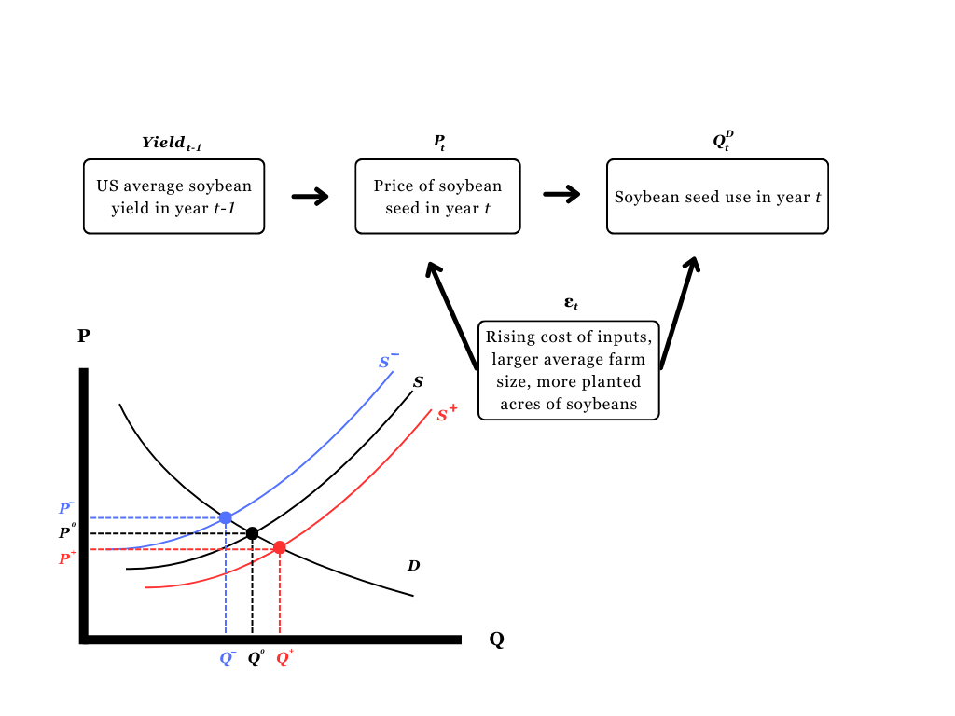

Pragmatically, we first regress MYA price on this instrumental variable, set aside the predicted or fitted values of price, then use those in the second stage where we would regress usage on (estimated) price and control variables. Our instrumental variable here is a linear combination of world corn production in the current year and the prior year. The first stage is weakly identified (not a strong statistical significance, but the correct sign and valid in the sense that world supplies don’t impact usage directly, only indirectly through prices) and so we continue to the second stage of estimation. In technical terms, we’re extracting the exogenous part of MYA price and using it in our demand curve estimation rather than the aggregation of the exogenous and endogenous parts of price, which fails to identify the demand curve we’re after.
Next is to formulate the demand model, keeping in mind that we only use the exogenous part of MYA price from the first stage from this point forward. The base model contains fixed effects for each decade 1970-2020, the MYA price (taken from first stage, and adjusted to 2025-equivalent dollars), and an Ethanol Boom pre/post indicator variable. There are other demographic and macroeconomic factors that need to be included in the demand model, but it is not immediately clear which combination of variables in addition to the base model produce the strongest fit. Therefore we use the stepwise algorithm which adds and removes all variables to and from the base model and picks the best AIC. The final variables are the base list, plus a PCE index, US population, world population, US GDP, world ending stocks, US ending stocks, and corn export competing countries’ exchange rate.
The second stage regression results are in Table 1
Term | Estimated Coefficient | t-statistic
Intercept | -209100 | -1.1900
MYA Price | -3507 | -2.9440***
PCE | 1445 | 1.5370
1970s | -23090 | -0.6680
1980s | -22250 | -0.7910
1990s | -42520 | -1.9920*
2000s | -23780 | -1.4360
2010s | -24000 | -2.0240**
Ethanol Boom | 16710 | 1.5890
US Population | 4.431 | 2.4290
US Ending Stocks | -0.2328 | -1.5560
Exchange Rate | -899.1 | -3.4620***
World Ending Stocks | 0.2958 | 3.5280***
World Population | -0.0001 | -1.9580*
US GDP | 0.2162 | 1.7200*
$R^{2}=0.98$, $F_{\left[14,41\right]}={169.8}^{***}$
Significance codes: “*”=10%, “**”=5%, “***”=1%

We have the expected negative slope on price, and an assortment of signs and magnitudes and significances on all the controls, which we won’t dwell on here. In English, the slope on price (the slope of the demand curve) says that if price increases $1/bu, then usage decreases 3,507.1 million bushels. The fit is strong overall, so this works as a preliminary framework to build out the demand index. Future refinements will be revisited as needed.
Next, we take the natural logarithm of price and usage and repeat the OLS estimation. This produces a transformed coefficient on (log of) price, which is no longer the slope of the demand curve but the own price elasticity of demand. We estimate this to be about -0.1651652067 (significant at the 1% level), a notably inelastic demand for corn as expected. For simplicity, we round this to -0.17 for the remainder of our work.
One point of caution is that we proceed with a constant elasticity of demand model for deriving the demand index and predicting future prices. With such a highly inelastic demand for corn, the price (i.e., the inverse demand curve) is going to be explosively sensitive to changes in usage, or more precisely, the relative supply. Since supply and usage are correlated 0.98, this confirms that we have a tight band that we can operate in when entertaining candidate values of these variables when predicting price.
No time like the present to move onto that constant elasticity of demand model. So, here we go: please press “stop” and turn the tape over to the next side, “Effect decomposition.docx”…

